Introduction à Seaborn

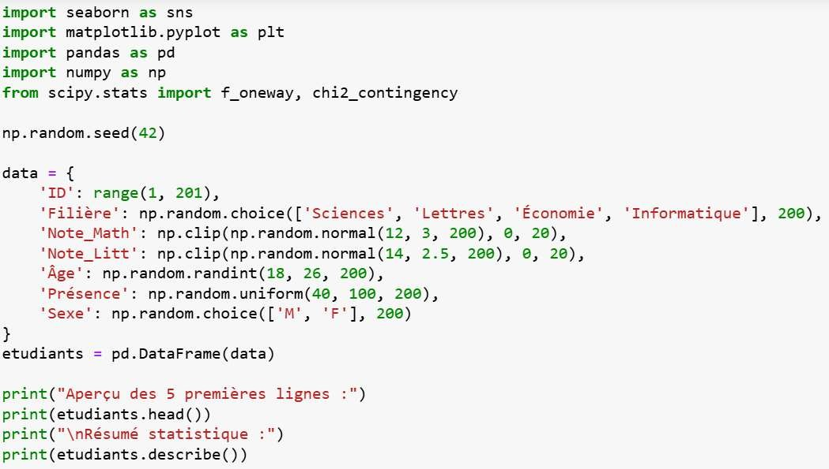

Cellule1

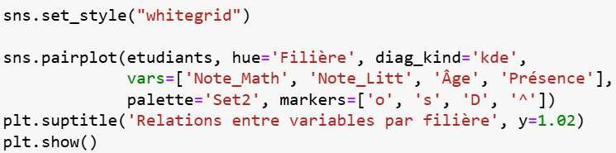

Cellule2

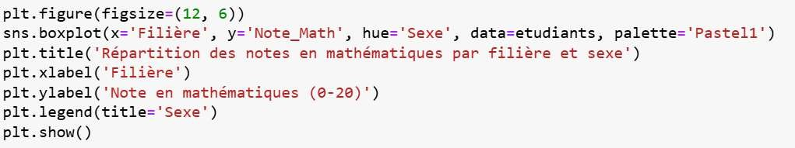

Cellule3

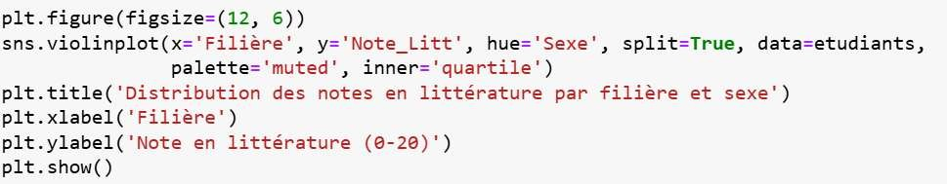

Cellule4

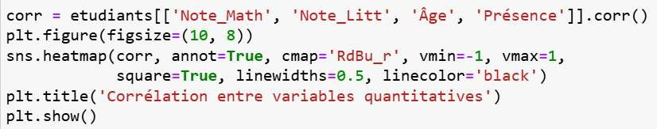

Cellule5

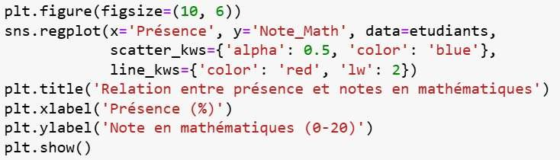

Cellule6

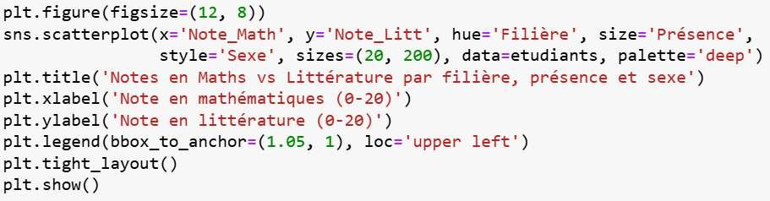

Cellule7

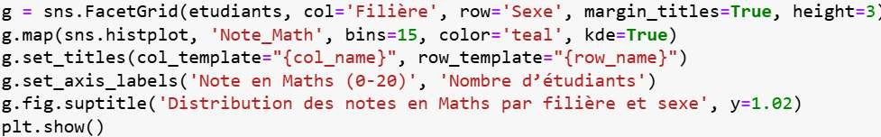

Cellule8

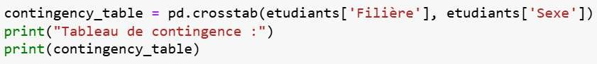

Cellule9

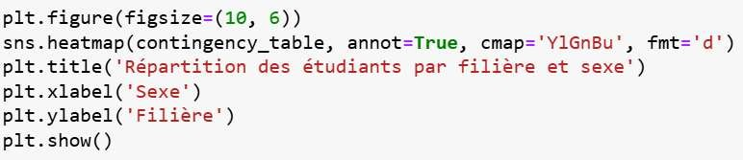

Cellule10

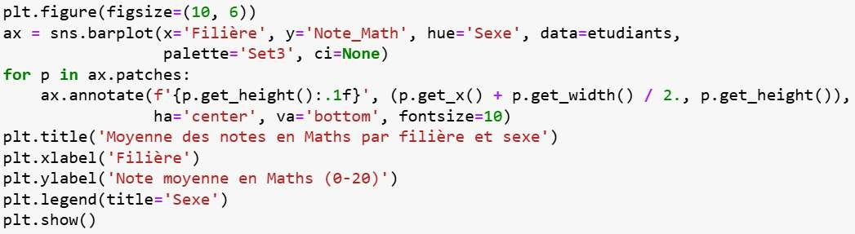

Cellule11

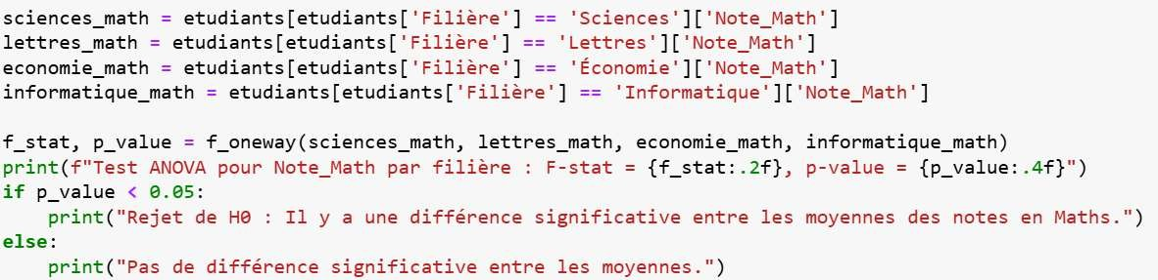

Cellule12

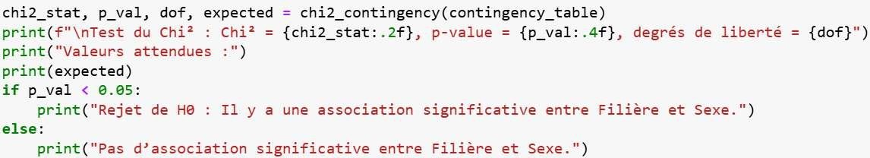

Cellule13

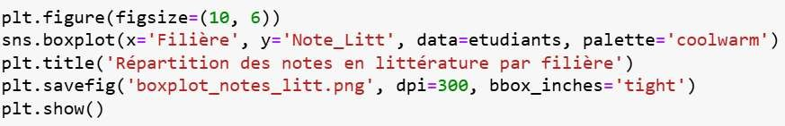

Cellule14